**Homework (Simulation) Wan Huzaifah bin Wan Azhar**

In this homework, we’ll use multi.py to simulate a multi-processor CPU scheduler, and learn some of its details.

**Answer:**

1. 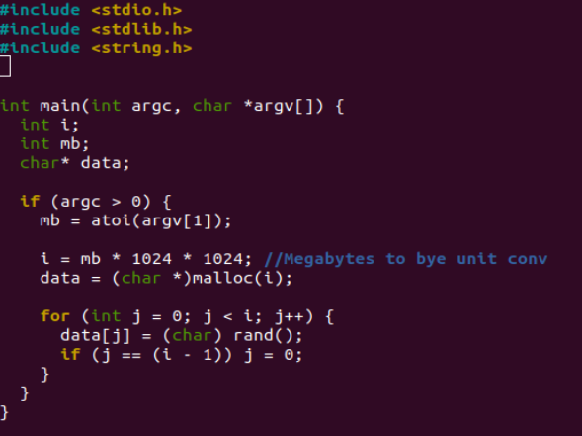

The script will take MB size and allocate it using Malloc indefinitely until user breaks it.

1. When allocating 100MB of space, the program will try to allocate exactly the amounts needed. From free tools, the used is increasing gradually to 100MB more. But, as system is unpredictable, it will not exactly allocate +100MB, but it is close enough that there is a difference.

When trying to allocate 10,000MB of space, the program breaks but there is no error displayed.

1. As expected, the 100MB allocated is at the heap section of the address space. That is because the char array is a data that is generated by the program.